Best Practice Lead
Job pack

Thanks for your interest in working at North Tyneside Citizens Advice. This job pack should give you everything you need to know to apply for this role and what it means to work at Citizens Advice.

In this pack you’ll find:
- Our values
- 3 things you should know about Citizens Advice
- Information about the organisation and role
- The role profile and person specification
- Our approach to equality and diversity
- The benefits of working at Citizens Advice

Our values
We’re inventive. We’re not afraid of trying new things and learn by getting things wrong. We question every idea to make it better and we change when things aren’t working.
We’re generous. We work together, sharing knowledge and experience to solve problems. We tell it like it is and respect everyone.
We’re responsible. We do what we say we’ll do and keep our promises. We remember that we work for a charity and use our resources effectively.
3 things you should know about Citizens Advice

1. We’re local and we’re national. We have 6 national offices and offer direct support to people in over 290 independent local Citizens Advice services across England and Wales.

2. We’re here for everyone. Our advice helps people solve problems and our advocacy helps fix problems in society. Whatever the problem, we won’t turn people away.

3. We’re listened to - and we make a difference. Our trusted brand and the quality of our research mean we make a real impact on behalf of the people who rely on us.

How North Tyneside Citizens Advice works
North Tyneside is part of the national citizens advice network. We have two main sites – North Shields and Wallsend – both are easily accessible by transport and road links as well as several outreaches around the district.

These sites offer face to face generalist advice as well as a telephone advice service.

North Tyneside also delivers specialist services in relation to money and benefit advice. We hold a regional contract Pensions advice.

In addition, together with Manchester Citizens advice we deliver a Debt Management Service

How Citizens Advice works

The Citizens Advice service is made up of Citizens Advice - the national charity - and a network of around 300 local Citizens Advice members.  This role sits in the national charity which includes  - 800 national staff working in one of our 6 offices or as homeworkers, or as part of the Witness Service from over 240 courts across England and Wales  - 3000 Witness Service volunteers  Our network members are all independent charities, delivering services from  - over 600 local Citizens Advice outlets  - over 1,800 community centres, GPs’ surgeries and prisons  They do this with:  - 6,500 local staff  - over 23,000 trained volunteers  Our reach means 99% of people in England and Wales can access a local Citizens Advice within a 30 minute drive of where they live. | 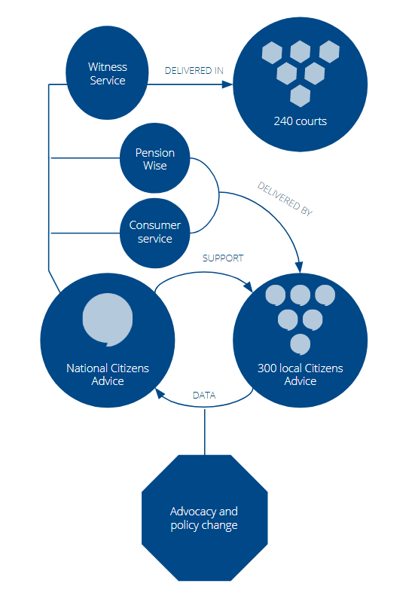

The role
Citizens Advice is set to deliver a new service called “Universal Support - Help to Claim” which offers end-to-end support to help people make a new Universal Credit claim and be ready for when their first payment arrives.

As part of this, the organisation is setting up a network of Best Practice Leads to gather and share learning about how Universal Credit and the Help to Claim service is performing, develop relationships with relevant local stakeholders and share ideas and best practice.

The role will work across a Jobcentre Plus district area to improve people’s experience of Universal Credit and Universal Support as well as feed into the wider Best Practice Lead network and work of national Citizens Advice.

Role profile
Job Title: | Universal Support Best Practice Lead - Job Ref: 20122/U
Reporting to: | Operations Manager
Salary: | £21,517.77 plus pension contribution
Location: | Based at North Shields with networking across Tyne and Wear
Role purpose: | - Gather learning and draw insight on how Universal Credit and Universal Support is working across a Jobcentre district.  - Work with other Best Practice Leads to develop an approach to sharing this learning with relevant partners including Jobcentres, local Citizens Advice and national Citizens Advice.  - Develop strong local relationships with relevant stakeholders including local Citizens Advice, Jobcentres, advice agencies and other voluntary sectors organisations.
Key accountabilities | Key elements/Tasks
Information gathering and feedback | - Continuously review the implementation of Universal Credit and Universal Support and share local and regional insight with relevant stakeholders.  - Gather feedback from other local Citizens Advice about how Universal Credit and Universal Support is performing and work with national colleagues to feed into appropriate channels such as Policy and Advocacy or Performance.  - Proactively identify emerging and potential issues with Universal Credit or Universal Support and take appropriate action such as liaising with the central Citizens Advice Universal Support team.  - Support advisors to record Universal Credit information accurately and gather case studies of people’s experiences.  - Contribute to the evaluation of work related to Universal Credit and Universal Support.  - Shareall relevant information in a clear and timely manner.
Sharing best practice | - Gather information from across the district about what works in relation to Universal Credit and Universal Support.  - Actively involve, share and communicate work being done across the service on Universal Credit and US.  - Feed into national Citizens Advice work on developing and sharing best practice.  - Encourage local offices across the district to share and adopt best practice.
Stakeholder relationships | - Develop and implement a district-wide stakeholder strategy including approach to:  - relationships with other local Citizens Advice which encourage the sharing of information and best practice around Universal Credit and Universal Support.  - relationships with Jobcentres at a district level and establishing channels for communicating issues and sharing information.  - relationships with other relevant local stakeholders with an interest in or potential intelligence about Universal Credit and Universal Support.  - Promote visibility and build support for the Universal Credit Help to Claim service.
Contribute to the development of the Best Practice Lead network | - Work both independently and collaboratively with others to find creative and innovative solutions.  - Use influencing, negotiation, persuasion skills to enable the delivery of positive solutions working with local Citizens Advice across the network.  - Develop coaching and mentoring skills.

Person specification

Key Essential Criteria
- Proven ability to analyse complex information and make decisions/formulate recommendations quickly, communicating information clearly and accessibly.

- Excellent interpersonal and communication skills including the ability to deliver presentations and build relationships with staff at all levels.

- Proven ability to influence and negotiate with senior managers, executives and external stakeholders.

- Proven ability to plan and work effectively under pressure to deadlines.

Requirements for role

- Awareness that Citizens Advice clients are at the heart of everything that we do.

- A proven commitment to continuing professional development of self and wider team.

- IT proficiency including competent use of Google and Microsoft Office.

- Ability to commit to and work within the values, aims, principles and policies of the Citizens Advice service in which equality and diversity is embedded throughout.

- Willingness and ability to work occasional unsocial hours and undertake some travel throughout the UK with some overnight stays.

